SIMATS ENGINEERING

LAB REPORT

Name : Yuvann Nithish R
Reg No : 192411267
Course Code :CSA4301
Course Name : Internet Programming

Experiment 1: Library Management System
Aim:
To design and develop a Library Management System webpage using HTML and CSS with navigation links, book search, student portal, study materials, and admin dashboard sections.
Procedure:
1. Create an HTML document with the basic structure.
2. Add a header with the title and navigation links such as Home, Login, Register, Books, Materials, and Contact.
3. Create a welcome banner with a description and a Get Started button.
4. Add feature cards for Book Search, Student Portal, Study Materials, and Admin Dashboard.
5. Create an About section and footer.
6. Link the external CSS file to style the webpage.
Code:
<!DOCTYPE html>
<html>
<head>
<title>Campus Library</title>
<style>
body{font-family:Arial;background:#eef2ff;text-align:center;padding:30px}
.container{background:white;padding:25px;max-width:500px;margin:auto;border-radius:12px}
input,button{padding:12px;margin:8px;border:1px solid #ccc;border-radius:6px}
button{background:#4338ca;color:white;cursor:pointer}
li{padding:8px;text-align:left}
</style>
</head>
<body>
<div class="container">
<h1>📚 Campus Library</h1>
<p>Library Book Management</p>
<input id="book" placeholder="Enter book name">
<button onclick="addBook()">Add Book</button>
<ul id="list"></ul>
</div>
<script>
function addBook(){
let b=document.getElementById('book');
if(b.value.trim()){
let li=document.createElement('li');
li.textContent=b.value;
document.getElementById('list').appendChild(li);
b.value='';
}}
</script>
</body>
</html>

OUTCOME:

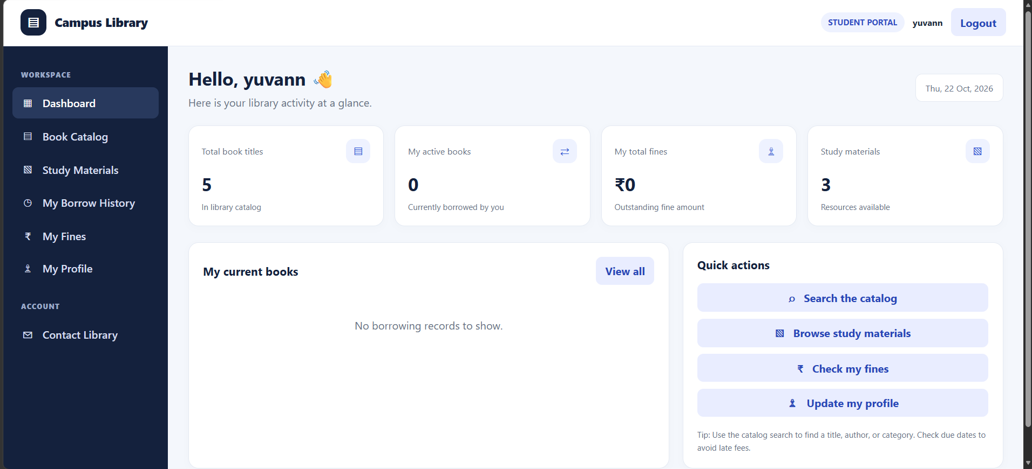

Result:
Thus, the Library Management System webpage was successfully designed using HTML and CSS with navigation links and different library-related sections.

Experiment 2: Hotel Room Booking System
Aim:
To design and develop a Hotel Room Booking System webpage that displays available rooms, accepts booking details, and shows booking history.
Procedure:
1. Create an HTML document and link the CSS and JavaScript files.
2. Design the header and navigation links for Home, Rooms, Book Room, Booking History, and Contact.
3. Display different room types, including Standard, Deluxe, Family, and Suite rooms, with their prices and facilities.
4. Create a booking form to collect the customer's name, email, phone number, room type, check-in date, check-out date, and number of guests.
5. Add JavaScript functions to select rooms and handle booking operations.
6. Create a booking history table to display reservation details.
7. Add contact information and a footer.
Code:

<!DOCTYPE html>
<html>
<head>
<title>StayScape Hotel</title>
<style>
body{font-family:Arial;background:#e0f2fe;text-align:center;padding:30px}
.box{background:white;padding:30px;max-width:450px;margin:auto;border-radius:15px}
input,select,button{width:90%;padding:12px;margin:8px;border-radius:6px;border:1px solid #ccc;box-sizing:border-box}
button{background:#0369a1;color:white}
</style>
</head>
<body>
<div class="box">
<h1>🏨 StayScape</h1><h3>Book Your Stay</h3>
<form onsubmit="event.preventDefault();result.innerText='Room booked successfully!'">
<input placeholder="Customer Name" required>
<input type="date" required>
<select required>
<option value="">Choose Room</option>
<option>Single Room</option>
<option>Double Room</option>
<option>Deluxe Room</option>
</select>
<button>Book Room</button>
</form>
<p id="result"></p>
</div>
</body>
</html>
Outcome:

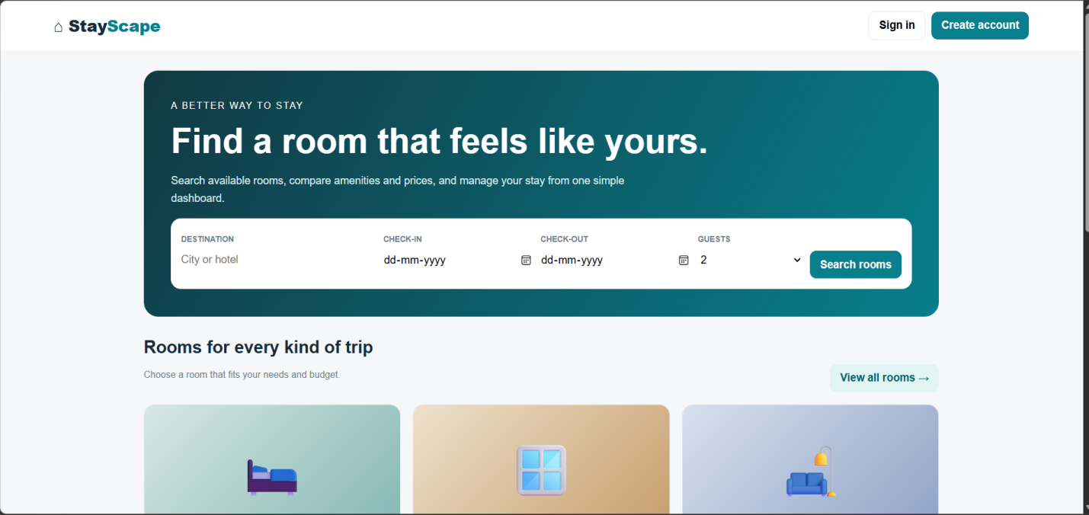

Result:
Thus, the Hotel Room Booking System webpage was successfully developed with room details, a booking form, and a booking history section.

Experiment 3: Bus Ticket Booking System
Aim:
To design and develop a Bus Ticket Booking System webpage that allows users to enter passenger details, book tickets, cancel tickets, and submit comments.
Procedure:
1. Create an HTML document and link the CSS and JavaScript files.
2. Add a header displaying the title Bus Ticket Booking System.
3. Create a ticket booking section with fields for passenger name, route, journey date, bus type, and seat number.
4. Add a Book Ticket button to handle ticket booking.
5. Create a cancellation section with a booking ID field and Cancel Ticket button.
6. Add a comments section with a text area and Submit button.
7. Use JavaScript functions to handle booking, cancellation, and comment submission.

CODE:

Outcome:
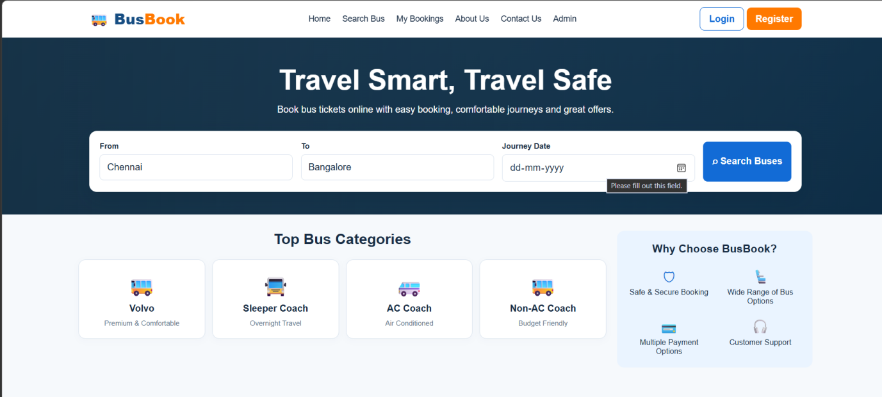
Code :
<!DOCTYPE html>
<html>
<head>
<title>BusBook</title>
<style>
body{font-family:Arial;background:#fff7ed;text-align:center;padding:30px}
.box{background:white;padding:25px;max-width:450px;margin:auto;border-radius:12px;box-shadow:0 3px 12px #ddd}
input,button{padding:12px;margin:8px;width:85%;box-sizing:border-box;border-radius:6px;border:1px solid #ccc}
button{background:#ea580c;color:white}
</style>
</head>
<body>
<div class="box">
<h1>🚌 BusBook</h1><h3>Book Your Journey</h3>
<form onsubmit="event.preventDefault();result.innerText='Bus ticket booked successfully!'">
<input placeholder="From City" required>
<input placeholder="Destination" required>
<input type="date" required>
<input type="number" placeholder="Passengers" min="1" required>
<button>Search & Book Bus</button>
</form>
<p id="result"></p>
</div>
</body>
</html>

Result:
Thus, the Bus Ticket Booking System webpage was successfully developed with ticket booking, cancellation, and customer comment sections.

Experiment 4: Train Reservation System
Aim:
To design and develop a Train Reservation System webpage that provides login, ticket booking, PNR status checking, and ticket cancellation features.
Procedure:
1. Create an HTML document and link the CSS and JavaScript files.
2. Design a header with the title Train Reservation System.
3. Create a login section with email and password fields.
4. Develop a ticket booking form with passenger name, source station, destination station, journey date, and travel class.
5. Add a Book Ticket button to handle reservation requests.
6. Create a PNR status section to check ticket status using a PNR number.
7. Add a ticket cancellation section using the PNR number.
8. Use JavaScript functions to handle login, booking, PNR status checking, and cancellation.

CODE:

<!DOCTYPE html>
<html>
<head>
<title>RailReserve</title>
<style>
body{font-family:Arial;background:#ecfdf5;text-align:center;padding:30px}
.box{background:white;padding:25px;max-width:450px;margin:auto;border-radius:12px}
input,select,button{width:90%;padding:12px;margin:8px;border:1px solid #ccc;border-radius:6px;box-sizing:border-box}
button{background:#047857;color:white}
</style>
</head>
<body>
<div class="box">
<h1>🚆 RailReserve</h1><h3>Train Reservation</h3>
<form onsubmit="event.preventDefault();result.innerText='Reservation successful!'">
<input placeholder="Departure Station" required>
<input placeholder="Arrival Station" required>
<input type="date" required>
<select required>
<option value="">Select Class</option>
<option>Sleeper</option>
<option>AC 3 Tier</option>
<option>AC 2 Tier</option>
</select>
<button>Reserve Ticket</button>
</form>
<p id="result"></p>
</div>
</body>
</html>

Outcome:
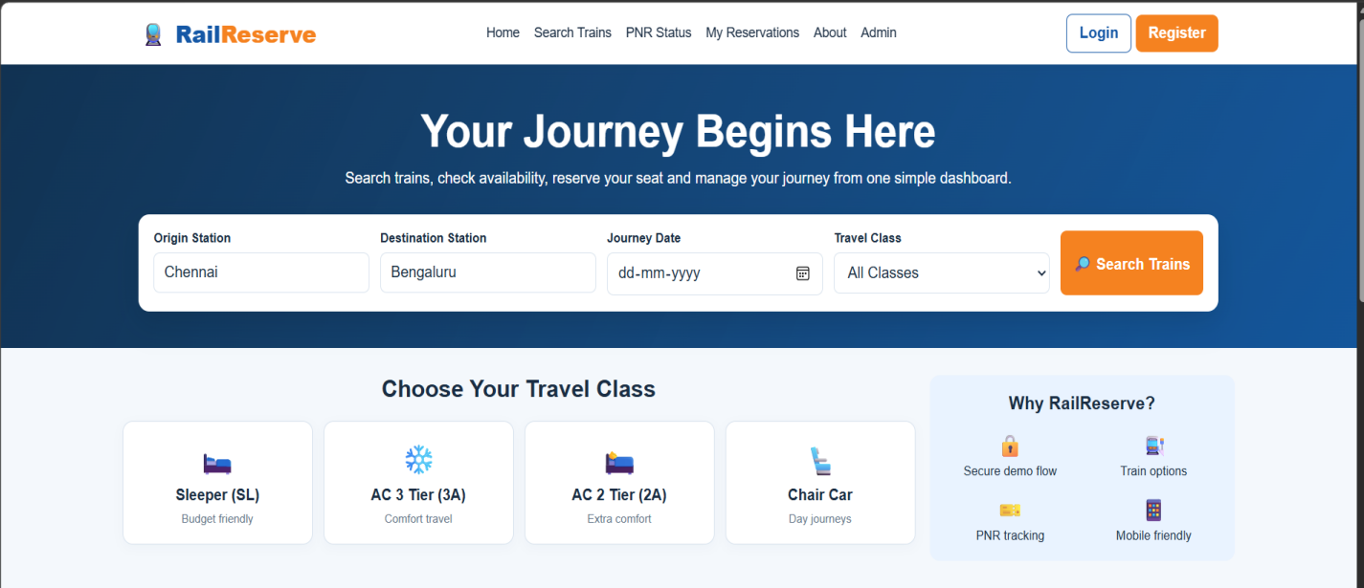

Result:
Thus, the Train Reservation System webpage was successfully developed with login, ticket booking, PNR status checking, and cancellation sections.

Experiment 5: Flight Reservation System
Aim:
To design and develop a Flight Reservation System webpage that provides flight searching, ticket booking, payment options, booking status checking, cancellation, customer feedback, and admin reports.
Procedure:
1. Create an HTML document and link the CSS and JavaScript files.
2. Design a header displaying the title Flight Reservation System.
3. Create a login section with email and password fields.
4. Develop a flight search form with source, destination, journey date, and flight class.
5. Add a ticket booking section to enter the passenger name and seat number.
6. Create a payment section with amount and payment mode options such as UPI, credit card, and debit card.
7. Add sections for checking booking status using a PNR number and cancelling tickets.
8. Create a customer feedback section with a text area and Submit button.
9. Display an admin report table containing flight numbers, booked seats, and available seats.
10. Use JavaScript functions to handle the different operations.

CODE:

<!DOCTYPE html>
<html>
<head>
<title>SkyBook Flights</title>
<style>
body{font-family:Arial;background:#eff6ff;text-align:center;padding:30px}
.box{background:white;padding:30px;max-width:450px;margin:auto;border-radius:15px;box-shadow:0 3px 15px #ddd}
input,button{width:90%;padding:12px;margin:8px;border:1px solid #ccc;border-radius:6px;box-sizing:border-box}
button{background:#2563eb;color:white}
</style>
</head>
<body>
<div class="box">
<h1>✈️ SkyBook</h1><h3>Find Your Flight</h3>
<form onsubmit="event.preventDefault();result.innerText='Flight reservation successful!'">
<input placeholder="From City" required>
<input placeholder="To City" required>
<input type="date" required>
<input type="number" placeholder="Passengers" min="1" required>
<button>Book Flight</button>
</form>
<p id="result"></p>
</div>
</body>
</html>

Outcome:
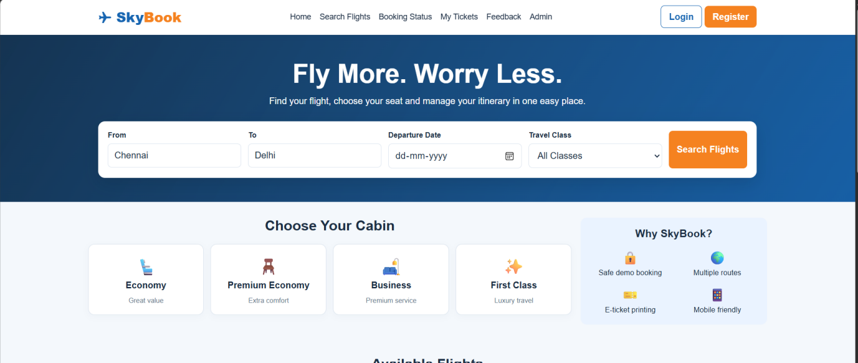

Result:
Thus, the Flight Reservation System webpage was successfully developed with flight search, ticket booking, payment options, booking status, cancellation, feedback, and admin report sections.

Experiment 6: Online Cake Ordering System
Aim:
To design and develop an Online Cake Ordering System using HTML, CSS, and JavaScript that allows users to browse cakes, register, log in, place orders, manage delivery addresses, and track order status, while enabling the admin to manage products and orders.
Procedure:
1. Create an HTML webpage with separate sections for Admin and Student (User).
2. Design the admin login page and provide options to manage products, post cake details, upload images, and manage orders.
3. Create user registration and login pages.
4. Display cakes with images, descriptions, categories, subcategories, and prices.
5. Implement search and filter options to help users find cakes based on their preferences and price range.
6. Provide options to view cake details, add cakes to the cart, and place orders.
7. Create forms to add and update shipping addresses.
8. Provide options to view order history and track shipping status.
9. Use CSS to create an attractive, responsive interface and JavaScript to handle user interactions.
10. Develop the admin panel to update order status and manage cake inventory.

CODE :

<!DOCTYPE html>
<html>
<head>
<title>CakeBloom</title>
<style>
body{font-family:Arial;background:#fdf2f8;text-align:center;padding:30px}
.box{background:white;padding:25px;max-width:450px;margin:auto;border-radius:15px}
input,select,button{width:90%;padding:12px;margin:8px;border:1px solid #ccc;border-radius:6px;box-sizing:border-box}
button{background:#db2777;color:white}
</style>
</head>
<body>
<div class="box">
<h1>🎂 CakeBloom</h1><h3>Order Your Favourite Cake</h3>
<form onsubmit="event.preventDefault();result.innerText='Cake order placed successfully!'">
<input placeholder="Customer Name" required>
<select id="cake" required>
<option value="">Select Cake</option>
<option value="500">Chocolate Cake - ₹500</option>
<option value="400">Vanilla Cake - ₹400</option>
<option value="600">Black Forest - ₹600</option>
</select>
<input id="qty" type="number" placeholder="Quantity" min="1" required>
<button>Place Order</button>
</form>
<p id="result"></p>
</div>
<script>
document.querySelector('form').onsubmit=function(e){
e.preventDefault();
result.innerText='Order placed! Total: ₹'+(cake.value*qty.value);
}
</script>
</body>
</html>

Outcome:
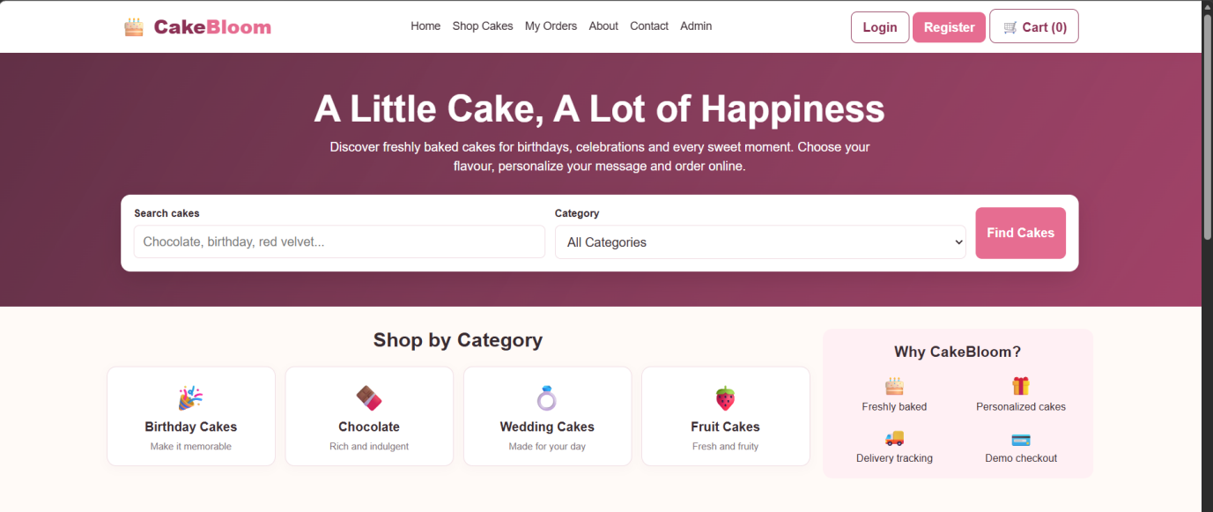

Result:
Thus, the Online Cake Ordering System was designed to provide cake browsing, searching, ordering, cart management, shipping address management, and order tracking features for users, along with product and order management features for the admin.

